TrackBack
TECHNICAL REPORT



SUBMITTED BY
Noor Fatima (2024-ag-4461)
ADVISED BY
Sir Qamar

A TECHNICAL REPORT SUBMITTED IN PARTIAL FULFILLMENT OF REQUIREMENT FOR THE DEGREE OF
BACHELOR OF SCIENCE
IN
Computer Science
DEPARTMENT OF COMPUTER SCIENCE
FACULTY OF SCIENCES
UNIVERSITY OF AGRICULTURE FAISALABAD
DECLARATION

I hereby declare that the contents of the report “TrackBack – Lost and Found Management System” is project of my own and no part has been copied from any published source (except the references). I further declare that this work has not been submitted for award of any other diploma/degree. The university may take action if the information provided is found false at any stage. In case of any default the scholar will be proceeded against as per UAF policy.

_________________
Noor Fatima
2024-ag-4461
CERTIFICATE

To,
The Controller of Examinations,
University of Agriculture,
Faisalabad.

The supervisory committee certify that Noor Fatima bearing 2024-ag-4461 has successfully completed his project in partial fulfillment of requirement for the degree of M.Sc. Computer Science under our guidance and supervision.

_____________________________________
Advisor Name
Department

_______________________________________
Dr. Muhammad Ahsan Latif
Chairman,
Department of Computer Science

ACKNOWLEDGEMENT

I thank all who in one way or another contributed to the completion of this report. I am so grateful to the Department of Computer Science for making it possible for me to study here. My special and heartily thanks to my advisor, Supervisor Name who encouraged and directed me. His/her challenges brought this work towards a completion. It is with his/her supervision that this work came into existence. For any faults, I take full responsibility. I am thankful to my fellow students whose challenges and productive critics have provided new ideas for the work. Furthermore, I also thank my family who encouraged me and prayed for me throughout the time of my research. May the Almighty God richly bless all of you

ABSTRACT

TrackBack is a desktop-based Lost and Found Management System developed using C# Windows Forms and SQLite database. The system addresses a common and persistent problem faced at university campuses where students and staff frequently lose personal belongings and have no organized, centralized way to report or recover them. Traditional informal methods such as WhatsApp messages and handwritten notice board posters are unreliable, reach limited audiences, and leave no permanent record.
This system provides a clean, secure, and easy-to-use digital platform where registered users can report lost or found items, search for active items, and submit ownership claims. The system supports two user roles: regular users and an administrator. Regular users can register, log in, report lost or found items, search all active items using keywords, and track the status of their submitted claims. The administrator has full control through a five-tab panel for managing users, items, and claims.
Security is implemented using BCrypt password hashing with a cost factor of 11, ensuring passwords are never stored as plain text. All SQL queries use parameterized inputs to prevent injection attacks. The codebase follows the Repository design pattern with a three-layer architecture separating the Presentation, Business Logic, and Data Access layers. The database contains five main tables: Users, Items, Categories, Locations, and Claims.
The system was thoroughly tested with six major test cases covering user login, wrong password handling, item reporting, claim submission, admin claim approval, and duplicate email prevention. All test cases passed successfully. TrackBack is a stable, secure, and deployable solution for university lost and found management.

Table of Contents
CHAPTER 1 - INTRODUCTION 2
1.1 Background 2
1.2 Description 2
1.3 Problem Statement 3
1.4 Scope 3
1.5 Objectives 3
1.6 Feasibility 3
1.6.1 Technical Feasibility 4
1.6.2 Schedule Feasibility 4
1.6.3 Economic Feasibility 4
1.6.4 Cultural Feasibility 4
1.6.5 Legal/Ethical Feasibility 4
1.6.6 Resource Feasibility 4
1.6.7 Operational Feasibility 4
1.7 Requirements 4
1.7.1 Functional Requirements 4
1.7.2 Non- Functional Requirements 5
1.7.3 Hardware Requirements 5
1.7.4 Software Requirements 5
1.8 Stakeholders 6
Chapter 2 – MATERIALS & METHODS 7
2.1 Process Model 7
Figure 1: Agile Activities 7
2.2 Tools & Technologies 7
2.3 Design 8
2.3.1 Use Case Diagrams 8
Figure 2.2 Use Case Diagram 8
2.3.2 Usage Scenario 8
2.3.3 Sequence Diagram: 14
2.3.4 Class Diagram: 15
2.3.5 Data Flow Diagram: 15
2.3.6 ER Diagram: 17
2.3.7 Database Model: 17
2.3.8 Architecture: 18
Chapter 3 - RESULTS & DISCUSSION 19
3.1 Testing 19
3.2 Test Cases 19
3.3 Conclusion 21
Chapter 4 - USER MANUAL 23
4.1 Login Screen 23
4.2 Registration Screen 23
4.3 User Dashboard 24
4.4 Report Lost / Register Found Item Screen 25
4.5 Search Items Screen 25
4.6 Admin Panel 26
CHAPTER 5 – TECHNICAL MANUAL 27
5.1 Introduction 27
5.2 System Overview 27
5.3 Development Environment Setup 27
5.4 Project Structure 27
5.5 Database Configuration 28
5.6 Security Implementation 28
5.7 Deployment Guide 28
5.8 Maintenance Guidelines 29
5.9 Known Limitations and Future Enhancements 29

List of Figures
Figure 2.1 Agile Activities 7
Figure 2.2 Use Case Diagram 8
Figure 2.3 Sequence Diagram 14
Figure 2.4 Class Diagram 15
Figure 2.5 Context Diagram 16
Figure 2.6 Level 1 DFD 16
Figure 2.7 Entity Relationship Diagram 17
Figure 2.8 Database Model 18
Figure 4.1 Login Screen 23
Figure 4.2 Registration Screen 24
Figure 4.3 User Dashboard 24
Figure 4.4 Report Item Screen 25
Figure 4.5 Search Items Screen 25
Figure 4.6 Admin Panel 26

List of Tables

Table 2.1: Use Case – Register 9
Table 2.2: Use Case – Login 9
Table 2.3: Use Case – Report Lost Item 10
Table 2.4: Use Case – Register Found Item 10
Table 2.5: Use Case – Search Items 11
Table 2.6: Use Case – Submit Claim 11
Table 2.7: Use Case – View My Claims 12
Table 2.8: Use Case – Verify Claims 12
Table 2.9: Use Case – Manage Lost Items 13
Table 2.10: Use Case – Manage Found Items 13
Table 2.11: Use Case – Manage Users 14
Table 2.12: Use Case – View Dashboard Statistics 14

Table 3.1: Test Case – User Login 19
Table 3.2: Test Case – Login with Wrong Password 19
Table 3.3: Test Case – Report Lost Item 20
Table 3.4: Test Case – Submit Claim 20
Table 3.5: Test Case – Admin Approve Claim 21
Table 3.6: Test Case – Duplicate Email Registration 21

CHAPTER 1 - INTRODUCTION

1.1 Background
Losing personal belongings is a frustrating experience that almost every student faces at some point during their time at a university. Items like mobile phones, wallets, keys, bags, water bottles, and stationery are commonly lost in libraries, cafeterias, classrooms, labs, and hostels. In most cases, the person who finds the item has no structured way to report it, and the person who lost it has no easy way to check if their item has been found.
The traditional method of handling lost and found items is informal and inefficient. Students either post messages in WhatsApp groups, put handwritten notices on notice boards, or ask around verbally. These approaches reach a very limited audience, expire quickly, and leave no permanent record. Important items are often never returned because the lost and found process is disorganized and relies entirely on chance.
University campuses in Pakistan, including UAF, have no dedicated digital system to manage this problem. The need for a simple, centralized, and permanent solution is clear. A software-based system where users can register, report items, and search for their belongings would dramatically improve the recovery rate and save students from the stress of losing their possessions permanently.

1.2 Description
TrackBack is a Windows-based desktop application developed in C# using the Windows Forms (WinForms) framework. It uses a local SQLite database to store and manage all system data. The application is designed specifically for university campus environments where a large number of users share common spaces every day.
The application supports two types of users. Regular users (students and staff) can register an account, log in, report a lost or found item, browse all currently active items in the system, search by keywords, and submit a claim for a found item they believe belongs to them. They can also view the full status of all their submitted claims and all items they have reported.
The second user type is the Administrator. The admin uses the same login screen but is directed to a separate Admin Panel. This panel has five organized tabs: a dashboard showing system-wide statistics, a tab showing all lost items, a tab showing all found items, a tab for reviewing and managing pending claims, and a tab for managing all registered users.
Security is implemented using BCrypt password hashing with a work factor of 11. No plain-text passwords are stored anywhere in the database. All database queries use parameterized SQL statements to prevent SQL injection. The code follows the Repository design pattern, which strictly separates database logic from the user interface, resulting in a clean, maintainable, and extensible codebase.

1.3 Problem Statement
Students at the University of Agriculture Faisalabad and similar institutions frequently lose personal belongings on campus. There is currently no centralized digital system to report lost items, register found items, or connect owners with finders. The existing informal methods such as WhatsApp messages and notice board posters are unreliable, temporary, and reach very few people. As a result, most lost items are never recovered, causing financial loss and inconvenience to students.
TrackBack solves this problem by providing a structured digital platform where items can be reported, searched, and claimed in an organized way, with admin oversight to verify and approve claims.

1.4 Scope
TrackBack covers all core functions of a lost and found management system for a university campus. The scope of the project includes:
- User registration and login with secure BCrypt password hashing
- Reporting of lost and found items with category, location, title, description, and date
- Searching all active items by keyword
- Submitting claims for found items with a message
- Admin management of all items, users, and claims
The system is limited to desktop use on Windows. It does not include email notifications, image attachments, a web or mobile interface, or real-time push notifications. These features are outside the current scope but can be added in future versions.

1.5 Objectives
The main objectives of the TrackBack system are:
- To provide a centralized platform for reporting and searching lost and found items on campus
- To make the process of claiming a found item transparent and organized
- To give the administrator full control over all system data and claim approvals
- To ensure user data security through BCrypt password hashing
- To implement a clean, maintainable code structure using the Repository design pattern

1.6 Feasibility
A feasibility study determines whether the proposed project is practical and achievable.
1.6.1 Technical Feasibility – The project is technically feasible because the required technologies such as C#, Windows Forms, SQLite, and Visual Studio are available and suitable for development.
1.6.2 Schedule Feasibility – The project can be completed within the semester duration because the modules are manageable and development tools are easily available.
1.6.3 Economic Feasibility – The project is economically feasible because free tools and technologies are used. No expensive hardware or software is required.
1.6.4 Cultural Feasibility – The system is culturally feasible because it supports a cooperative and responsible environment within the university campus.
1.6.5 Legal/Ethical Feasibility – The system does not violate any legal or ethical policies. User information is stored securely and used only for system operations..
1.6.6 Resource Feasibility – The required resources such as computers, development software, internet access, and database systems are available.
1.6.7 Operational Feasibility – The system is easy to use for students and staff. Users can easily report and search items through a simple graphical interface.

1.7 Requirements

1.7.1 Functional Requirements
FR01: User Registration
FR01-01 | System shall allow users to create accounts.
FR01-02 | System shall collect user details.
FR01-03 | System shall validate unique email addresses
FR01-04 | System shall save user information in database.
FR02: User Login
FR02-01 | System shall allow users to enter email and password.
FR02-02 | System shall authenticate user credentials
FR02-03 | System shall redirect valid users to dashboard
FR02-04 | System shall display error message for invalid login
FR03: Report Lost Item
FR03-01 | System shall allow users to report lost items.
FR03-02 | System shall collect item details
FR03-03 | System shall save item information in database
FR04: Report Found Item
FR04-01 | System shall allow users to report found items.
FR04-02 | System shall collect item details
FR04-03 | System shall save found item data.
FR05: Search Items
FR05-01 | System shall allow users to search items.
FR05-02 | System shall display matching results
FR06: Submit Claim
FR06-01 | System shall allow users to claim items.
FR06-02 | System shall save claim information
FR06-03 | System shall notify admin about claim.
FR07: Admin Management
FR07-01 | Admin shall manage users.
FR07-02 | Admin shall manage items.
FR07-03 | Admin shall approve or reject claims.

1.7.2 Non- Functional Requirements
NFR01: System should remain available 24/7 to its users.
NFR02: System should have two types of users.
NFR03: The system should provide secure authentication.
NFR04: The system should provide fast response time.
NFR05: The system should provide user-friendly interface.
NFR06: The database should maintain data integrity.
NFR07: The system should support multiple records efficiently.
NFR08: The system should remain stable during operations

1.7.3 Hardware Requirements
- Processor: Intel Core i3 or higher
- RAM: 4 GB minimum
- Storage: 500 MB free space
- Hard Disk: 500GB or higher
- Keyboard, Monitorand Mouse

1.7.4 Software Requirements
- Visual Studio 2022 (Community Edition)
- C# (WinForms)
- SQLite 3 (via System.Data.SQLite)
- BCrypt.Net-Next NuGet package

Stakeholders
The main stakeholders of the TrackBack system are:
- Students: Primary users who report and search for lost and found items
- University Staff: Also users who may lose or find items on campus
- Administrator: Manages the entire system, verifies claims, and oversees all data
- University Management: Benefits from a more organized campus lost and found process

Chapter 2 – MATERIALS & METHODS

2.1 Process Model
TrackBack was developed using the Agile development process model. Agile is an iterative and incremental software development methodology that emphasizes flexibility, collaboration, and delivering working software in short cycles called sprints. Instead of completing the entire design phase before writing any code, Agile allows developers to plan, build, test, and review each feature in a short cycle and then move on to the next.
For this project, development was divided into four main sprints. Sprint 1 covered the database design and connection layer. Sprint 2 covered user authentication (registration and login). Sprint 3 covered item reporting, search, and claims. Sprint 4 covered the Admin Panel and final testing. After each sprint, the output was reviewed, tested, and any corrections were incorporated before the next sprint began.

Figure 1: Agile Activities

2.2 Tools & Technologies
Tool / Technology | Purpose
Windows Forms (WinForms) | Graphical user interface framework
SQLite 3 | Lightweight local relational database
System.Data.SQLite | SQLite ADO.NET driver for .NET
BCrypt.Net-Next | Password hashing library (NuGet package)
MS Visual Studio 2022 | Integrated development environment
DB Browser for SQLite | Database inspection and schema verification tool

2.3 Design

2.3.1 Use Case Diagrams
A Use Case Diagram represents the functional requirements of a system from the end user's perspective. It shows the actors (users of the system) and the use cases (functionalities) they can perform. The diagram below captures all major interactions between the two actors — User and Admin — and the TrackBack system.

Use Case Diagram:
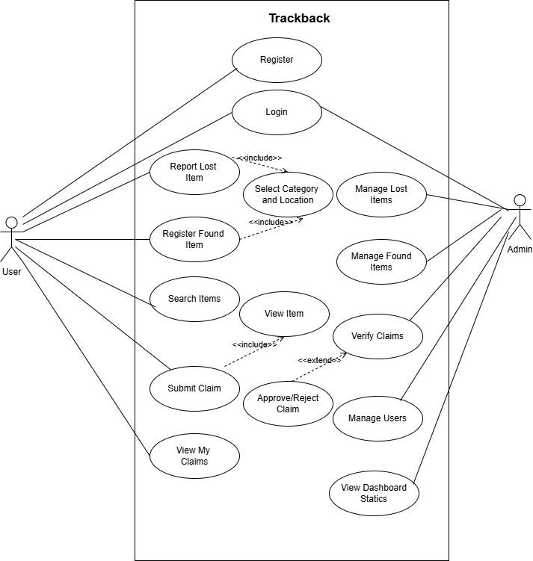

Figure 2.2 Use Case Diagram

2.3.2 Usage Scenario
A usage scenario (also called a use case specification) describes the step-by-step interaction for each use case in the use case diagram.
Table 2.1: Use Case – Register
Use Case Title | Register
Use Case ID | UC-01
Actor | New User
Description | New user creates an account by filling Full Name, Email, Phone, Department, Password.
Pre-Conditions | App is running. Email not already registered.
Task Sequence | 1. User opens Registration form.2. Fills all fields and clicks Register.3. System validates inputs and checks email uniqueness.4. Password hashed with BCrypt and user saved.5. Success message shown, form closes.
Exceptions | Empty field :warning shown.Duplicate email :error shown.Password mismatch :Confirm field cleared.
Post-Conditions | Account created with Role = User. User can now login.

Table 2.2: Use Case – Login
Use Case Title | Login
Use Case ID | UC-02
Actor | User, Administrator
Description | Registered user authenticates and is redirected to Dashboard (User) or Admin Panel (Admin).
Pre-Conditions | App is running. Account exists in database.
Task Sequence | 1. User enters Email and Password, clicks Login.2. System retrieves record and verifies password via BCrypt.3. Admin → Admin Panel opens. User → Dashboard opens.
Exceptions | Empty fields → warning.Wrong credentials → error, password field cleared.
Post-Conditions | User authenticated and on correct form.

Table 2.3: Use Case – Report Lost Item
Use Case Title | Report Lost Item
Use Case ID | UC-03
Actor | Logged-in User
Description | User reports a lost item with title, category, location, description, and date.
Pre-Conditions | User logged in. Categories and Locations exist in DB.
Task Sequence | 1. User clicks Report Lost Item on Dashboard.2. Fills Title, Category, Location, Date (optional Description).3. Clicks Submit. System saves item (ItemType = Lost, Status = Active).4. Smart match check runs — user notified if matches found.
Exceptions | Empty Title or unselected dropdown → warning shown.
Post-Conditions | Item saved. Visible in My Items on Dashboard.

Table 2.4: Use Case – Register Found Item
Use Case Title | Register Found Item
Use Case ID | UC-04
Actor | Logged-in User
Description | User registers a found item so its owner can search and claim it.
Pre-Conditions | User logged in. Categories and Locations exist in DB.
Task Sequence | 1. User clicks Register Found Item on Dashboard.2. Fills Title, Category, Location, Date.3. Clicks Submit. System saves item (ItemType = Found, Status = Active).4. Smart match check runs — user notified if matches found.
Exceptions | Empty Title or unselected dropdown → warning shown.
Post-Conditions | Item saved. Visible in Search Items screen and Admin Found Items tab.

Table 2.5: Use Case – Search Items
Use Case Title | Search Items
Use Case ID | UC-05
Actor | Logged-in User
Description | User views all active items and filters them by keyword.
Pre-Conditions | User logged in.
Task Sequence | 1. User opens Search Items screen.2. All active items load (Lost = red, Found = blue).3. User types keyword and clicks Search to filter by title or description.4. User clicks Clear to reset list.
Exceptions | No keyword match → empty grid shown.
Post-Conditions | User views items and may proceed to submit a claim.

Table 2.6: Use Case – Submit Claim
Use Case Title | Submit Claim
Use Case ID | UC-08
Actor | Logged-in User
Description | User submits a claim for a Found item they believe belongs to them.
Pre-Conditions | User logged in. Found item exists from a different user. No duplicate claim exists.
Task Sequence | 1. User selects a Found item in Search Items.2. Clicks Claim. System checks: not own item, not duplicate.3. User enters claim message in dialog.4. System saves claim with Status = Pending.
Exceptions | Own item → blocked.Duplicate claim → blocked.Empty message → not submitted.
Post-Conditions | Claim saved (Status = Pending). Visible in user's My Claims on Dashboard.

Table 2.7: Use Case – View My Claims
Use Case Title | View My Claims
Use Case ID | UC-10
Actor | Logged-in User
Description | User views all claims they have submitted with status (Pending/Approved/Rejected) and admin notes.
Pre-Conditions | User logged in. Dashboard loaded.
Task Sequence | 1. Dashboard loads user's claims from DB.2. Claims shown in My Claims grid with status colors (Pending = yellow, Approved = blue, Rejected = red).3. Stats box shows total and pending claim counts.
Exceptions | No claims → grid is empty.
Post-Conditions | User is aware of status of all their submitted claims.

Table 2.8: Use Case – Verify Claims
Use Case Title | Verify Claims
Use Case ID | UC-12
Actor | Administrator
Description | Admin reviews all pending claims to assess their legitimacy before taking action.
Pre-Conditions | Admin logged in. Pending claims exist.
Task Sequence | 1. Admin opens Claims tab in Admin Panel.2. All Pending claims loaded: Claim ID, Item, Claimed By, Message, Date.3. Admin reads messages and proceeds to Approve or Reject (UC-11).
Exceptions | No pending claims → grid is empty.
Post-Conditions | Admin has reviewed claims and taken action via UC-11.

Table 2.9: Use Case – Manage Lost Items
Use Case Title | Manage Lost Items
Use Case ID | UC-13
Actor | Administrator
Description | Admin views all active Lost items and can delete those with no attached claims.
Pre-Conditions | Admin logged in.
Task Sequence | 1. Admin opens Lost Items tab. All active Lost items load.2. Admin selects a row and clicks Delete.3. System shows confirmation dialog.4. If no claims attached → item deleted. Grid refreshes.
Exceptions | Item has claims → deletion blocked: 'Cannot delete — claims exist.'No row selected → warning.
Post-Conditions | Item deleted from DB (if no claims). Grid refreshes.
Table 2.10: Use Case – Manage Found Items
Use Case Title | Manage Found Items
Use Case ID | UC-14
Actor | Administrator
Description | Admin views all active Found items and can delete those with no attached claims.
Pre-Conditions | Admin logged in.
Task Sequence | 1. Admin opens Found Items tab. All active Found items load.2. Admin selects a row and clicks Delete.3. Confirmation dialog shown.4. If no claims attached → item deleted. Grid refreshes.
Exceptions | Item has claims → deletion blocked.No row selected → warning.
Post-Conditions | Item deleted from DB (if no claims). Grid refreshes.

Table 2.11: Use Case – Manage Users
Use Case Title | Manage Users
Use Case ID | UC-15
Actor | Administrator
Description | Admin views all registered users and can delete accounts that have no items in the system.
Pre-Conditions | Admin logged in.
Task Sequence | 1. Admin opens Users tab. All registered users load.2. Admin selects a user and clicks Delete.3. System checks: not admin's own account, user has no items.4. If checks pass → user deleted. Grid refreshes.
Exceptions | Own account → blocked: 'You cannot delete yourself!'User has items → blocked: 'Cannot delete — user has items.'
Post-Conditions | User account deleted (if eligible). Grid refreshes.

Table 2.12: Use Case – View Dashboard Statistics
Use Case Title | View Dashboard Statistics
Use Case ID | UC-16
Actor | Administrator
Description | Admin views live system statistics on the Admin Panel dashboard tab.
Pre-Conditions | Admin logged in. Admin Panel open.
Task Sequence | 1. Admin opens Dashboard tab (loads by default on login).2. System queries DB for 6 counts: Total Lost, Total Found, Total Claimed, Pending Claims, Recovered Items, Total Users.3. Values displayed in stat boxes. Refreshes every time tab is switched to.
Exceptions | DB query failure → error message, stats may show 0.
Post-Conditions | Admin has overview of all current system activity.

2.3.3 Sequence Diagram:
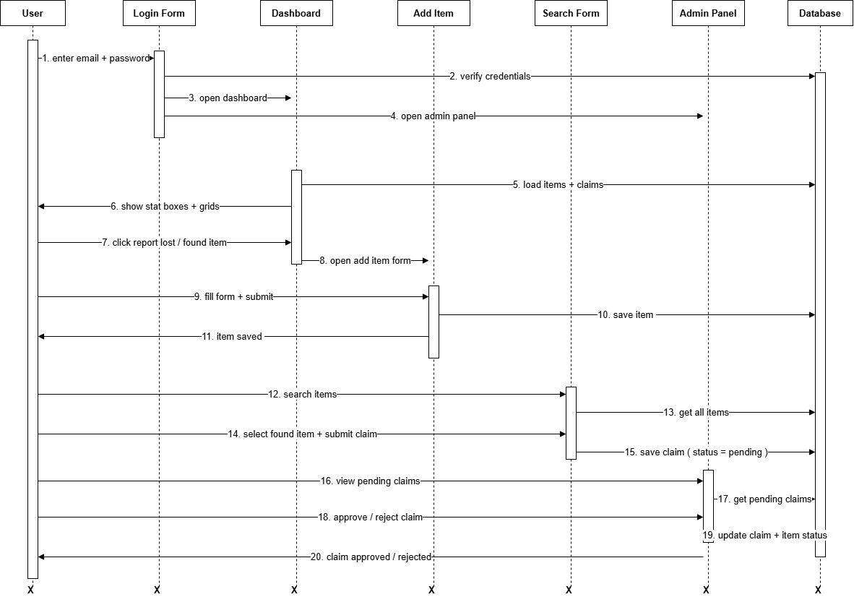

Figure 2.3 Sequence Diagram

2.3.4 Class Diagram:
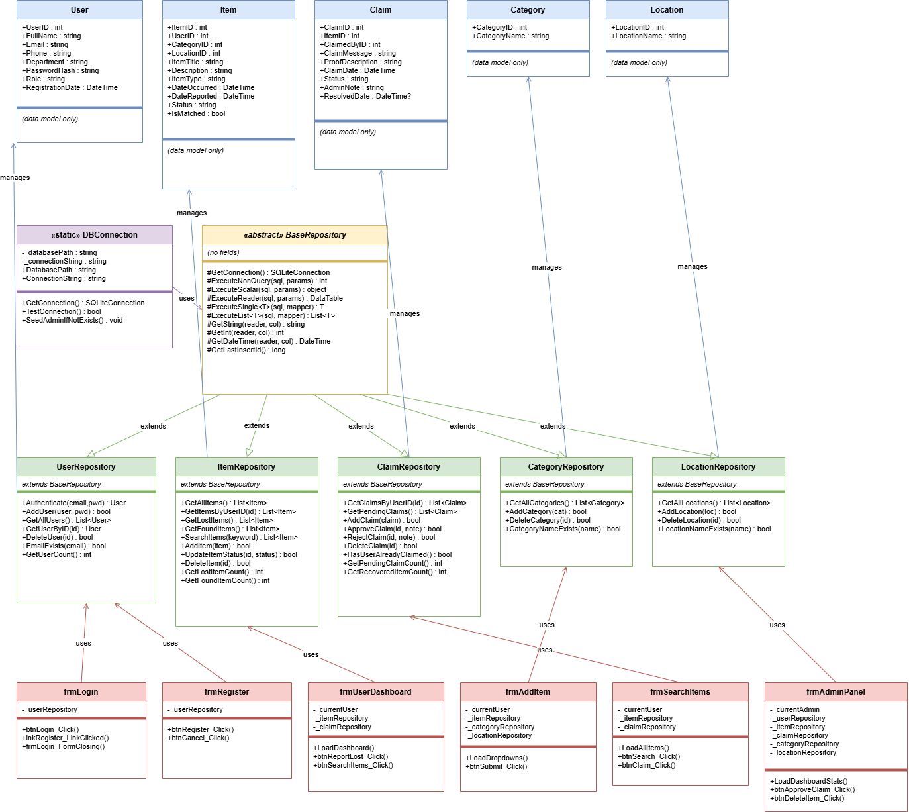

Figure 2.4 Class Diagram

2.3.5 Data Flow Diagram:
A Data Flow Diagram (DFD) shows how data moves through a system. It uses four symbols: external entities (rectangles), processes (circles or rounded rectangles), data stores (open rectangles), and data flows (arrows).

Context Diagram (Level 0):
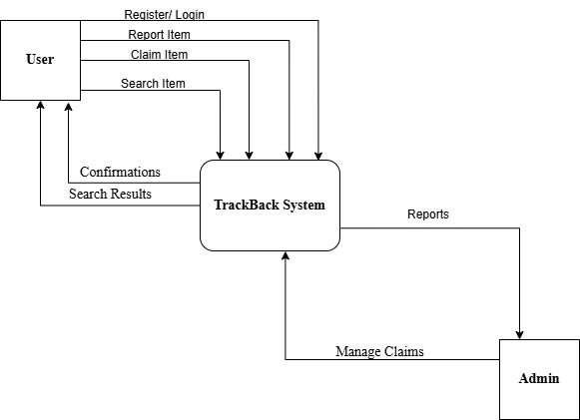
Figure 2.5 Context Diagram

Level 1 DFD:
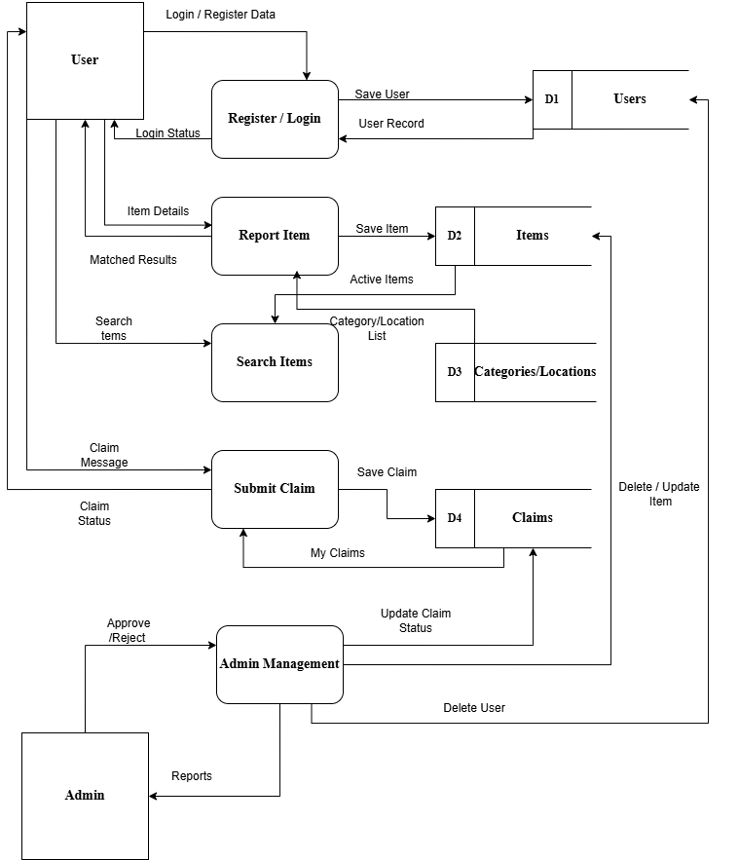
Figure 2.6 Level 1 DFD

2.3.6 ER Diagram:
The Entity Relationship (ER) Diagram shows the logical structure of the database, the entities, their attributes, and the relationships between them. The TrackBack database has five entities: Users, Items, Categories, Locations, and Claims.

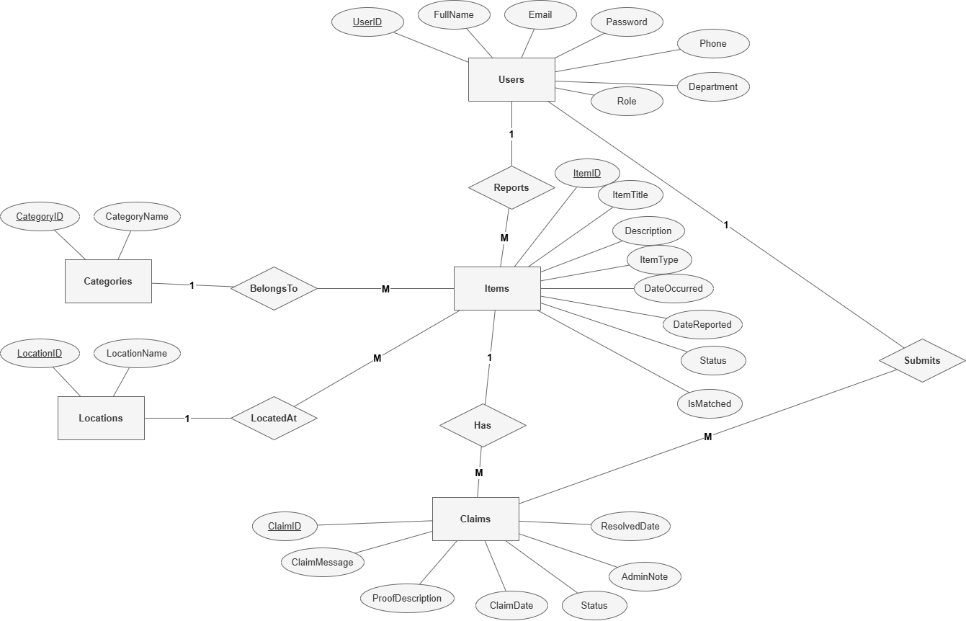

Figure 2.7 Entity Relationship Diagram

2.3.7 Database Model:
The database model shows the physical structure of the database tables, their columns, data types, primary keys, and foreign key relationships as they exist in SQLite
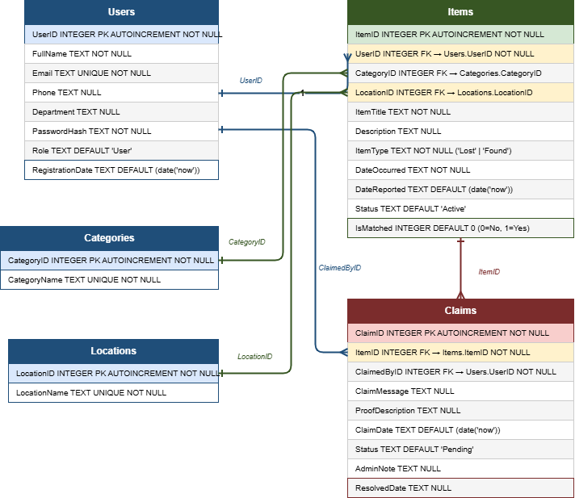

Figure 2.8 Database Model

2.3.8 Architecture:
TrackBack uses a 3-Tier (Three-Layer) Architecture that cleanly separates the system into three independent layers:
Layer | Components | Responsibility
Presentation Layer | frmLogin, frmRegister, frmUserDashboard, frmAdminPanel, frmAddItem, frmSearchItems | All user interface forms. Handles user input, validation, and displaying results.
Business / Application Layer | Repository Classes (UserRepository, ItemRepository, ClaimRepository, etc.), Models (User, Item, Claim, Category, Location) | Contains all application logic, data mapping, and validation rules.
Data Access Layer | BaseRepository, DBConnection, SQLite Database (db.sqlite) | Manages all database connections, query execution, and data persistence.

This layered architecture ensures that changes in one layer do not affect the others. For example, switching from SQLite to a different database in the future would only require changes in the Data Access Layer, leaving all forms and repositories unchanged.

Chapter 3 - RESULTS & DISCUSSION

3.1 Testing
Software testing was carried out throughout the development of TrackBack to ensure all features work correctly and the system handles both valid and invalid inputs properly. Both functional testing (checking what the system does) and validation testing (checking that inputs are handled correctly) were performed.
Testing was done manually by running each feature and comparing the actual result with the expected result. All major use cases were covered by test cases. The results of testing are presented below.

3.2 Test Cases
Test Case: User Login:
Table 3.1: Test Case – User Login
Test Case ID: | TC-01
Test Case Title: | Verify login with correct credentials
Priority: | High
Requirement: | User Login
Description: | Test that a registered user can log in with correct email and password
Pre-Conditions: | Application is running. A registered user account exists in the database.
Test Steps: | 1. Enter valid email address 2. Enter correct password 3. Click Login
Test Data: | Email: testuser@uaf.edu.pk | Password: test1234
Expected Result: | System opens User Dashboard and shows welcome message with user name
Actual Result: | User Dashboard opened successfully with correct user name
Post Conditions: | User is on the dashboard with their items and claims loaded
Status: | PASS

Test Case : Login with Wrong Password:
Table 3.2: Test Case – Login with Wrong Password
Test Case ID: | TC-02
Test Case Title: | Verify login with wrong password
Priority: | High
Requirement: | User Login Security
Description: | Test that incorrect password is rejected and no access is granted
Pre-Conditions: | Application is running. A registered user account exists.
Test Steps: | 1. Enter valid email 2. Enter wrong password 3. Click Login
Test Data: | Email: testuser@uaf.edu.pk | Password: wrongpass
Expected Result: | Error message shown: Invalid email or password. Password field cleared.
Actual Result: | Error message shown. Password field cleared. No access granted.
Post Conditions: | User remains on Login form
Status: | PASS

Test Case: Report Lost Item:
Table 3.3: Test Case – Report Lost Item
Test Case ID: | TC-03
Test Case Title: | Report a lost item successfully
Priority: | High
Requirement: | Report Lost Item
Description: | Test that a user can report a lost item and it is saved in the database
Pre-Conditions: | User is logged in. Categories and Locations exist in the database.
Test Steps: | 1. Click Report Lost Item on dashboard 2. Enter item title 3. Select category and location 4. Set date occurred 5. Click Submit
Test Data: | Title: Blue Water Bottle | Category: Accessories | Location: Library
Expected Result: | Success message shown. Item appears in My Items list on dashboard.
Actual Result: | Item saved and visible in My Items list with correct details.
Post Conditions: | Item stored in database with ItemType = Lost and Status = Active
Status: | PASS

Test Case: Submit Claim:
Table 3.4: Test Case – Submit Claim
Test Case ID: | TC-04
Test Case Title: | Submit a claim for a found item
Priority: | High
Requirement: | Submit Claim
Description: | Test that a user can claim a Found item and it is saved as Pending
Pre-Conditions: | User is logged in. A Found item exists that belongs to a different user.
Test Steps: | 1. Open Search Items 2. Select a Found item 3. Click Claim 4. Enter claim message 5. Click Submit
Test Data: | Item: Samsung Charger | Message: I lost this charger in the library yesterday
Expected Result: | Claim saved with Status Pending. Visible in My Claims section.
Actual Result: | Claim saved and visible. Status shows Pending.
Post Conditions: | Claim stored in database with Status = Pending
Status: | PASS

Test Case: Admin Approve Claim:
Table 3.5: Test Case – Admin Approve Claim
Test Case ID: | TC-05
Test Case Title: | Admin approves a pending claim
Priority: | High
Requirement: | Approve Claim
Description: | Test that admin can approve a claim and item status updates correctly
Pre-Conditions: | Admin is logged in. At least one Pending claim exists.
Test Steps: | 1. Open Claims tab in Admin Panel 2. Select a Pending claim 3. Click Approve 4. Enter admin note 5. Confirm
Test Data: | Admin note: Proof verified. Item returned.
Expected Result: | Claim status = Approved. Item status = Claimed. User dashboard shows updated status.
Actual Result: | Claim updated to Approved. Item updated to Claimed.
Post Conditions: | Claim and Item both updated in database. Claim list refreshed.
Status: | PASS

Test Case: Duplicate Email Registration:
Table 3.6: Test Case – Duplicate Email Registration
Test Case ID: | TC-06
Test Case Title: | Block registration with duplicate email
Priority: | Medium
Requirement: | User Registration
Description: | Test that the system prevents two accounts from using the same email
Pre-Conditions: | An account already exists with the test email.
Test Steps: | 1. Fill registration form 2. Use same email as existing account 3. Click Register
Test Data: | Email: testuser@gmail.com(already registered)
Expected Result: | Error message: Email already registered. Form stays open.
Actual Result: | Error message shown. No new account created.
Post Conditions: | Database unchanged
Status: | PASS

3.3 Conclusion
The TrackBack Lost and Found Management System was successfully developed and tested. All six major test cases passed without issues. The system correctly handles user registration, login, item reporting, item searching, claim submission, and admin claim management.
Security was properly implemented. Passwords are never stored as plain text. BCrypt hashing ensures that even if the database is accessed without authorization, passwords remain protected. All SQL queries use parameterized inputs to prevent SQL injection attacks.
The user interface is clean and easy to use. Each form has clear labels, validation messages, and focused error handling. The Admin Panel organizes all management tasks into clearly labeled tabs. New users can understand and use the system without training.
The code architecture follows the Repository design pattern with a layered structure. This makes the code easy to maintain and extend. Adding new features such as email notifications or mobile access would not require rewriting existing code, only adding new layers on top of the existing structure.Overall, TrackBack meets all the functional and non-functional requirements defined in Chapter 1. The system is stable, secure, and ready for deployment in a university environment.

Chapter 4 - USER MANUAL

4.1 Login Screen
The Login screen is the first screen that appears when the application starts. It has two fields: Email and Password. Enter your registered email and password and click the Login button. If the credentials are correct, the system will open either the User Dashboard (for regular users) or the Admin Panel (for admins). If the credentials are wrong, an error message will appear and the password field will be cleared. To register a new account, click the Register link at the bottom.

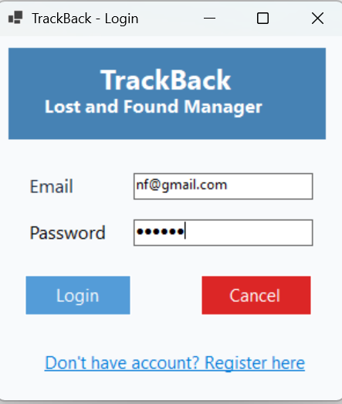
Figure 4.1 Login Screen

4.2 Registration Screen
The Registration screen allows new users to create an account. Fill in all five fields: Full Name, Email, Phone, Department, and Password. Re-enter the password in the Confirm Password field. Click Register to save the account. If any field is left empty, the system will show a warning and move the cursor to the empty field. If the email is already registered, an error message will appear. On success, the form closes and you are returned to the Login screen.

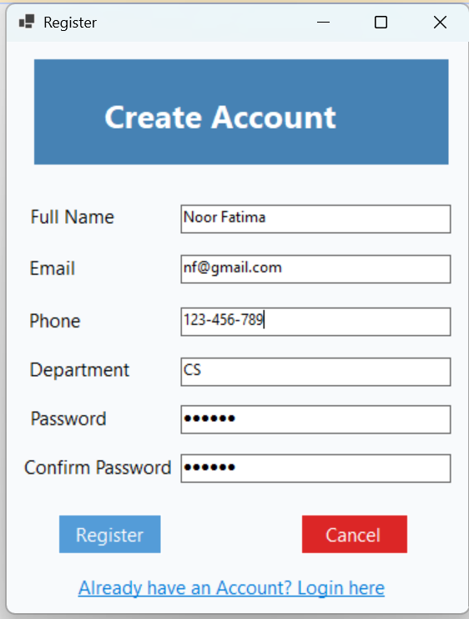
Figure 4.2 Registration Screen

4.3 User Dashboard
The User Dashboard is the main screen for regular users. At the top, it shows four statistics: total items you have reported, how many of those are lost, how many are found, and how many of your claims are pending. Below are three sections in tabs or panels: My Items (all items you have reported), My Claims (all claims you have submitted and their current status), and action buttons to Report Lost Item, Register Found Item, Search Items and Edit Selected Item.
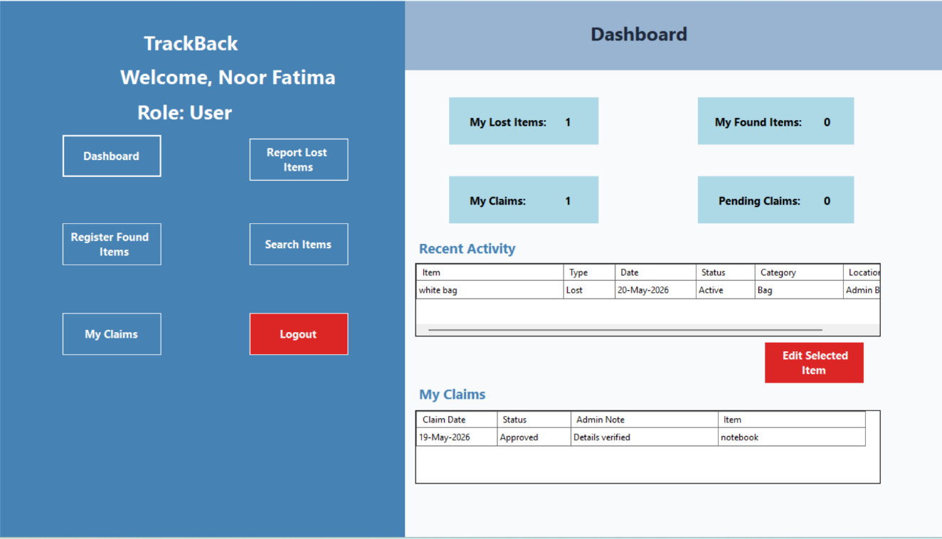
Figure 4.3 User Dashboard

4.4 Report Lost / Register Found Item Screen
This screen is used to add a new item to the system. When opened from Report Lost Item, the form is pre-set to Lost type. When opened from Register Found Item, it is pre-set to Found type. Fill in the Item Title, select a Category from the dropdown, select a Location from the dropdown, enter a Description (optional), and set the date the item was lost or found using the date picker. Click Submit to save. After saving, a success message will appear and the form will close.
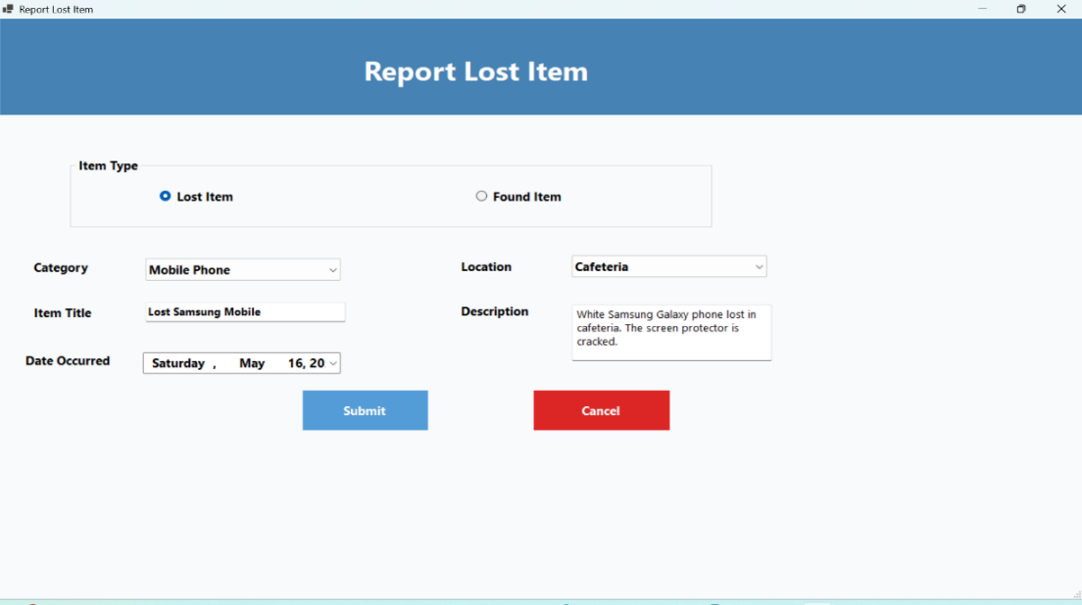
Figure 4.4 Report Item Screen

4.5 Search Items Screen
The Search Items screen shows all active items in the system (both Lost and Found). You can type a keyword in the search box and click Search to filter items by title or description. To submit a claim for a Found item, select the row and click the Claim button. A dialog will appear asking for your claim message and proof description. Note that you cannot claim your own items or an item you have already claimed before. Only Found items can be claimed.
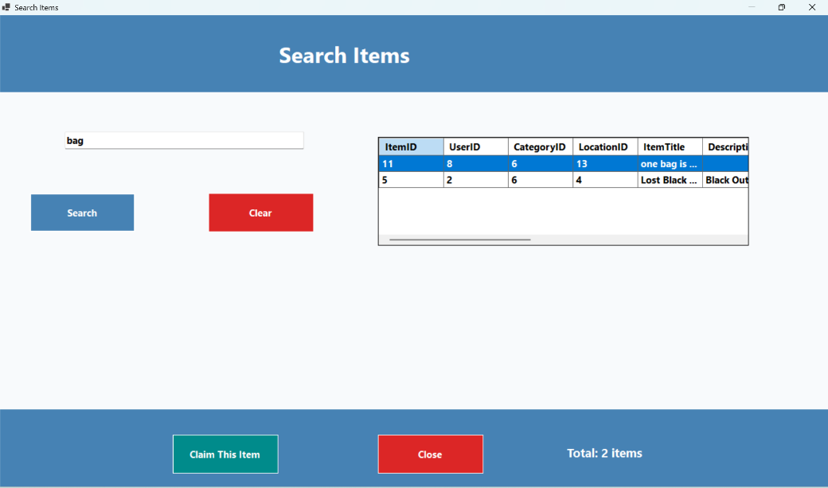
Figure 4.5 Search Items Screen

4.6 Admin Panel
The Admin Panel has five tabs at the top
Tab 1 – Dashboard:
Shows six statistics: Total Lost Items, Total Found Items, Total Claimed Items, Pending Claims, Recovered Items, and Total Users. These numbers update every time you switch to this tab.
Tab 2 – Lost Items:
Shows all active Lost items reported by all users. Each row shows the item ID, title, category, location, who reported it, status, and date. You can select a row and click Delete to remove an item (only if no claims are attached to it).
Tab 3 – Found Items:
Shows all active Found items. Same layout as Lost Items tab. You can delete items the same way.
Tab 4 – Claims:
Shows all Pending claims. Each row shows the claim ID, item title, who claimed it, their message, status, and claim date. Select a row and click Approve to approve the claim (item status will also change to Claimed). Click Reject to reject with a note.
Tab 5 – Users:
Shows all registered users. Each row shows UserID, full name, email, phone, department, and registration date. You can delete a user only if they have no items reported in the system.
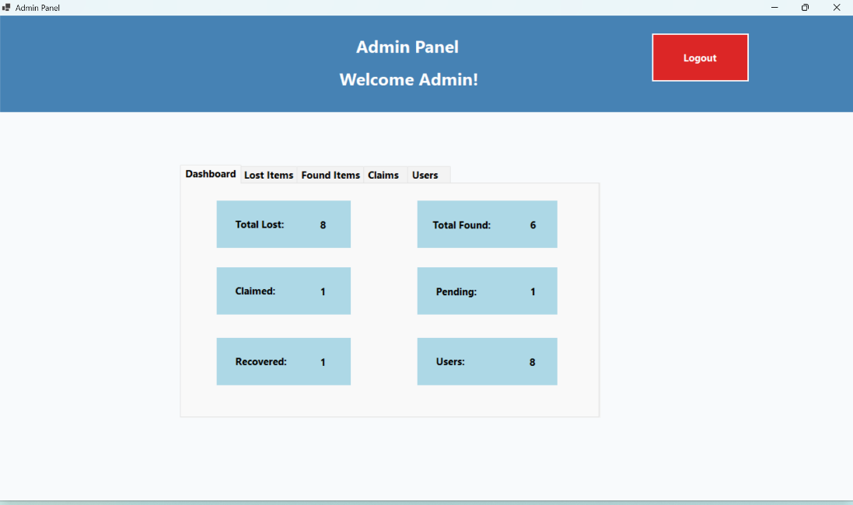
Figure 4.6 Admin Panel

CHAPTER 5 – TECHNICAL MANUAL

5.1 Introduction
This technical manual provides a complete reference for developers and system administrators who need to understand, install, configure, or extend the TrackBack system. It covers the system architecture, development environment setup, database structure, and guidelines for future maintenance.

5.2 System Overview
TrackBack is a desktop-based Lost and Found Management System developed using C# Windows Forms and a local SQLite database. The application follows a three-layer architecture consisting of a Presentation Layer (WinForms), an Application Layer (Repository classes and Models), and a Data Access Layer (SQLite via ADO.NET). All data is stored locally in a single file database (db.sqlite), which makes the system lightweight and easy to deploy.

5.3 Development Environment Setup
The following tools and configurations are required to open, build, and run the TrackBack project from source code.
IDE | Microsoft Visual Studio 2022 (Community or higher)
Language | C# ( .NET 8 , Windows Forms)
Database | SQLite 3 (via System.Data.SQLite NuGet package)
Password Hash | BCrypt.Net-Next (NuGet package)
Target OS | Windows 10 / Windows 11 (64-bit)
Runtime | .NET 8 Desktop Runtime

Steps to set up the development environment:
- Install Visual Studio 2022 with the .NET Desktop Development workload enabled.
- Open the solution file TrackBack.sln in Visual Studio.
- Restore NuGet packages: go to Tools → NuGet Package Manager → Restore Packages. This will automatically download System.Data.SQLite and BCrypt.Net-Next.
- Build the solution using Ctrl+Shift+B or Build → Build Solution.
- Run the application using F5 (Debug) or Ctrl+F5 (without debug).
- The database file db.sqlite is created automatically in the application directory on first run.

5.4 Project Structure
The project is organized into the following folders inside the Trackback solution:

Forms/ | All Windows Forms UI files (.cs and .Designer.cs). Includes frmLogin, frmRegister, frmUserDashboard, frmAdminPanel, frmAddItem, frmSearchItems.
Models/ | Plain C# model classes mapping to database tables: User, Item, Claim, Category, Location.
Database/ | Data access layer. Contains DBConnection.cs (SQLite connection), BaseRepository.cs (abstract base), and individual repository classes for each model.
Program.cs | Application entry point. Initializes the database and launches frmLogin.
db.sqlite | SQLite database file. Auto-created on first run. Stores all application data.

5.5 Database Configuration
The application uses SQLite as its database engine. The database file is stored in the same directory as the application executable. The connection string is defined in DBConnection.cs as follows:

Data Source=db.sqlite;Version=3;

The database is initialized automatically when the application starts for the first time. The InitializeDatabase() method in DBConnection.cs creates all five tables if they do not already exist. No manual database setup is required. The five tables are: Users, Items, Categories, Locations, and Claims.
Default seed data (categories and locations) is inserted on first run. A default admin account is also created with the credentials set in Program.cs, which should be changed after first login.

5.6 Security Implementation
- All passwords are hashed using BCrypt with a work factor of 11 before being stored. Plain-text passwords are never written to the database.
- All SQL queries use parameterized inputs (@parameter syntax) to prevent SQL injection attacks.
- Role-based access is enforced at login. Admin users are redirected to the Admin Panel; regular users are directed to the User Dashboard. No UI element is accessible without successful authentication.

5.7 Deployment Guide
To deploy TrackBack on a new Windows machine:
- Install the .NET 8 Desktop Runtime from https://dotnet.microsoft.com/download/dotnet/8.0.
- Copy the published build folder (produced by Build → Publish in Visual Studio) to the target machine.
- Run Trackback.exe. The application creates db.sqlite in the same folder automatically.
- No internet connection, external database server, or additional software is required.
- To migrate existing data to a new machine, copy the db.sqlite file along with the application folder.

5.8 Maintenance Guidelines
The following guidelines should be followed when extending or maintaining the TrackBack system:
- All new database tables must have a corresponding Model class in the Models/ folder and a Repository class in the Database/ folder inheriting from BaseRepository.
- Any new form must authenticate the user before loading. Check that the current user session is valid on form load.
- Avoid writing SQL queries directly in form code. All database operations must go through the Repository layer.
- When adding new columns to existing tables, update the corresponding Model class, Repository INSERT/SELECT queries, and the InitializeDatabase() CREATE TABLE statement.
- The db.sqlite file should be backed up regularly. Because all data is in a single file, a simple file copy is sufficient for backup.

5.9 Known Limitations and Future Enhancements
The following limitations exist in the current version of TrackBack and are suggested for resolution in future releases:
Image Attachments | Users cannot attach photos of lost or found items. A future version should support image upload and storage.
Email Notifications | The system does not send email alerts when a claim is approved or matched. SMTP integration is recommended.
Web / Mobile Access | The application is desktop-only. A web-based or mobile version using ASP.NET Core or a REST API would significantly extend its reach.
Multi-Admin Support | Currently only one admin account is supported. Role management should be extended to allow multiple admins with separate access logs.

